**2**

**E-LEARNING PLATFORM**

**MINI PROJECT REPORT**

Submitted by:

**PRITVI R (231801129)**

K RAMYA DEVI (231801136)

CS23332 DATABASE MANAGEMENT SYSTEM

Department of Artificial Intelligence and Data Science

Rajalakshmi Engineering College, Thandalam

**2024-2025**

**BONAFIDE CERTIFICATE**

Certified that this project report “**E-LEARNING PLATFORM**” is the bonafide work of **“PRITVI R (231801129),K RAMYA DEVI (231801136)”**

who carried out the project work under my supervision.

**Submitted for the Practical Examination held on**

**SIGNATURE SIGNATURE**

|  |  |  |  |  |
| --- | --- | --- | --- | --- |
| **Dr. GNANASEKAR J M** | **Dr. MANORANJINI J** | **Dr.GNANASEKAR J M** | **Dr. MANORANJINI J** | **Dr.MANORANJINI J** |
| **Head of the Department, Artificial intelligence**  **and data Science,Rajalakshmi Engineering College (Autonomous),Chennai-602105** | **Assoc.Professor, Artificial Intelligence and Data**  **Science, Rajalakshmi Engineering College (Autonomous), Thandalam, Chennai-602105** | |  | | --- | | **Head of the Department, Artificial intelligence**  **and data Science,Rajalakshmi Engineering College (Autonomous),Chennai-602105** | | **Professor, Artificial Intelligence and Data**  **Science, Rajalakshmi Engineering College (Autonomous), Thandalam, Chennai-602105** | **Associate Professor, Artificial Intelligence and Data Science, Rajalakshmi Engineering College,(Autonomous), Thandalam, Chennai-602105** |

**INTERNAL EXAMINER EXTERNAL EXAMINER**

**TABLE OF CONTENT**

|  |  |  |
| --- | --- | --- |
| **S.NO** | **CHAPTER** | **PAGE NUMBER** |
| 1. | **INTRODUCTION** |  |
| 1.1 | GENERAL | 7 |
| 1.2 | OBJECTIVES | 7 |
| 1.3 | SCOPE | 8 |
| 2. | **SYSTEM OVERVIEW** |  |
| 2.1 | SYSTEM ARCHITECTURE | 9 |
| 2.2 | MODULES OVERVIEW | 10 |
| 2.3 | USER ROLES AND ACCESS LEVELS | 11 |
| 3. | **SURVEY OF TECHNOLOGIES** |  |
| 3.1 | SOFTWARE AND TOOLS USED | 12 |
| 3.2 | PROGRAMMING LANGUAGES | 12 |
| 3.3 | FRAMEWORKS AND LIBRARIES | 13 |
| 4. | **REQUIREMENTS AND ANALYSIS** |  |
| 4.1 | FUNCTIONAL REQUIREMENTS | 14 |
| 4.2 | NON-Functional Requirements | 14 |
| 4.3 | HARDWARE AND SOFTWARE REQUIREMENTS | 14 |
| 4.4 | ARCHITECTURE DIAGRAM | 14 |
| 4.5 | ER DIAGRAM | 15 |

|  |  |  |  |
| --- | --- | --- | --- |
| 5. | **SYSTEM DESIGN** | |  |
| 5.1 | DATABASE DESIGN AND TABLES | | 16 |
| 5.2 | UI DESIGN OVERVIEW | | 16 |
| 5.3 | WORKFLOW AND PROCESS DIAGRAMS | | 17 |
| 6. | **IMPLEMENTATION** | |  |
| 6.1 | CODE STRUCTURE AND ORGANIZATION | | 18 |
| 6.2 | KEY MODULES AND THEIR FUNCTIONS | | 20 |
| 6.3 | CHALLENGES AND SOLUTIONS | | 21 |
| 7. | **TESTING AND VALIDATION** | |  |
| 7.1 | TESTING STRATEGIES | | 22 |
| 7.2 | TEST CASES AND RESULTS | | 22 |
| 7.3 | BUG FIXES AND IMPROVEMENTS | | 23 |
| 8. | **RESULTS AND DISCUSSION** | |  |
| 8.1 | SUMMARY OF FEATURES | | 24 |
| 8.2 | USER EXPERIENCE FEEDBACK | | 24 |
| 8.3 | POTENTIAL IMPROVEMENTS | | 25 |
| 9 | **CONCLUSION** | | 28 |
| 10 | **REFERENCES** | 29 | |

**TABLE OF FIGURES**

|  |  |  |
| --- | --- | --- |
| **S.NO** | **FIGURE** | **PAGE NUMBER** |
| 1 | ARCHITECTURE DIAGRAM | 14 |
| 2 | ER DIAGRAM | 15 |
| 3 | WORK FLOW DIAGRAM | 17 |
| 4 | DASHBOARD | 26 |
| 5 | LOGIN | 26 |
| 6 | COURSES,INSTRUCTORS | 27 |
| 7 | PPROGRESS | 27 |
|  |  |  |
|  |  |  |
|  |  |  |
|  |  |  |
|  |  |  |
|  |  |  |
|  |  |  |
|  |  |  |

## ABSTRACT

The *E-Learning Platform Management System* is a comprehensive web application designed to facilitate efficient management of online educational activities. This project focuses on streamlining the interaction between students and the platform by providing functionalities such as course browsing, instructor details, and progress tracking through a user-friendly interface. The system is developed using Flask as the back-end framework, MySQL for database management, and HTML/CSS for the front-end.

The primary objective of this system is to simplify the management of educational data, allowing students to view available courses, enroll in them, and track their academic progress. The login module ensures secure access to the platform, while session management enables personalized experiences for each user. A dashboard serves as the central hub for accessing course details, instructors' profiles, and performance metrics.

The system architecture adopts a client-server model, which ensures scalability, security, and efficient data flow. MySQL serves as the backbone for storing critical information such as student details, course data, enrollment records, and progress reports. The integration of these components ensures real-time updates, secure interactions, and a seamless user experience.

This project demonstrates how modern web technologies can be used to address the challenges of managing educational resources effectively. With features like personalized dashboards, secure authentication, and a well-structured database, the system aims to enhance both the learning experience for students and the efficiency of managing e-learning platforms. The platform is scalable and adaptable, making it suitable for institutions aiming to expand their online learning capabilities.

**1. INTRODUCTION**

* 1. **General**

The rapid growth of online learning has revolutionized the education sector, providing accessibility to knowledge and resources on an unprecedented scale. Managing the myriad aspects of e-learning platforms, including course offerings, student progress tracking, and instructor information, requires an efficient and scalable system. The *E-Learning Platform Management System* is designed to address these challenges by offering a streamlined solution that simplifies educational data management while enhancing user experience.

This project focuses on creating a web-based platform where students can seamlessly interact with course catalogs, view instructor details, enroll in courses, and monitor their academic progress. The system combines a robust back-end framework using Flask, an organized relational database in MySQL, and an intuitive front-end developed with HTML and CSS to deliver a holistic solution.

At its core, the *E-Learning Platform Management System* facilitates user authentication, ensuring secure access to personalized dashboards. Once logged in, students can explore available courses, track their performance, and gain insights into their learning journey. By automating routine administrative tasks such as enrollment tracking and progress monitoring, the system not only enhances operational efficiency but also empowers students to take control of their educational pursuits.

This platform is built with scalability and flexibility in mind, catering to the needs of modern educational institutions and students alike. The project demonstrates how technology can transform traditional education management into a more efficient, accessible, and user-focused process. Designed as a mini-project, it also serves as a practical implementation of concepts in database management, web development, and application architecture, offering a foundation for more advanced learning systems.

**1.2 Objectives**

The *E-Learning Platform Management System* aims to address the challenges of managing online education by offering a streamlined, secure, and user-friendly platform for students and educational institutions. A key objective is to organize and retrieve educational data efficiently, including information on students, courses, instructors, enrollments, and progress. The system ensures data integrity and security through a well-structured database implemented in MySQL. To maintain user privacy and security, the platform incorporates a login module with robust authentication, ensuring that only authorized users can access the system and their personalized dashboards.

Another crucial objective is to simplify the course browsing and enrollment processes. Students can explore available courses, view details, and enroll seamlessly through an intuitive interface, while the system automatically updates enrollment records in real time. The platform also emphasizes personalized progress tracking, enabling students to monitor their performance, including course completion statuses and grades, fostering self-assessment and informed decision-making about their learning goals.

The project provides a centralized dashboard designed for user-friendly navigation, where students can access course details, instructor profiles, and progress reports with ease. Enhancing the overall learning experience, the platform empowers students to take control of their educational journeys and supports scalability for future enhancements, making it adaptable to evolving e-learning needs.

.

**1.3 Scope**

The *E-Learning Platform Management System* is designed to streamline and enhance the management of educational processes in an online learning environment. Its scope encompasses various functionalities aimed at improving user experience, data organization, and the efficiency of e-learning platforms. The system caters primarily to students and educational institutions, offering features that address the needs of modern digital education.

From a student’s perspective, the platform provides a seamless interface to explore available courses, view instructor details, and enroll in desired programs. Additionally, it allows students to track their academic progress, including course completion status and grades, fostering self-assessment and active participation in their learning journeys. By providing a secure login system and personalized dashboards, the platform ensures that each student’s data is protected and accessible only to them.

For educational institutions, the system facilitates the effective management of course catalogs, instructor information, and enrollment records. The integration of a MySQL database ensures reliable storage and retrieval of data, maintaining the integrity and consistency of records. The platform’s architecture supports scalability, making it adaptable to institutions of various sizes and capable of accommodating future expansions or enhancements.

**2. SYSTEM OVERVIEW**

**2.1 System Architecture**

The *E-Learning Platform Management System* is built on a modular and scalable architecture that integrates various technologies to ensure efficiency, reliability, and seamless interaction between users and the platform. The system architecture adopts a client-server model, comprising three key layers: the Presentation Layer, the Application Layer, and the Data Layer.

1. Presentation Layer

The presentation layer, or the front end, is responsible for the user interface and interaction. It is designed using HTML, CSS, and Flask’s templating engine. This layer includes the login page, course details page, instructor details page, and student progress dashboard. It provides a user-friendly and intuitive interface that allows students to interact with the system effortlessly. The front end is optimized for clarity, ensuring that users can easily navigate through different functionalities.

2. Application Layer

The application layer forms the core logic of the system and is implemented using the Flask framework. This layer handles:

* Routing: Directs user requests to the appropriate modules and pages (e.g., login, courses, progress).
* Session Management: Maintains user sessions to ensure personalized and secure access.
* Data Processing: Fetches and processes data from the database based on user interactions, such as displaying course details or progress reports.
* Validation: Ensures the correctness and security of inputs, such as login credentials.

This layer acts as a bridge between the user interface and the database, ensuring that requests are processed and results are delivered efficiently.

3. Data Layer

The data layer is the backbone of the system, implemented using MySQL. It consists of tables that store critical information such as:

* Students Table: Contains details like student names, email addresses, and passwords.
* Courses Table: Stores course titles, descriptions, and other metadata.
* Instructors Table: Maintains instructor profiles and associated courses.
* Enrollments Table: Tracks which students are enrolled in which courses.
* Progress Table: Records students’ completion statuses and grades.

**2.2 Modules Overview**

The *E-Learning Platform Management System* is composed of several interconnected modules, each designed to handle specific functionalities and provide an efficient and seamless user experience. These modules work collaboratively to address the requirements of both students and the platform administrators. The key modules include:

1. User Authentication Module

This module ensures secure access to the system by verifying user credentials during the login process.

* Login Functionality: Users are required to enter their email and password to gain access. The system validates these credentials against the data stored in the Students table.
* Session Management: Once authenticated, a session is initiated to provide personalized access and retain user-specific data throughout the session.
* Security Measures: Prevents unauthorized access by enforcing strict validation of login details and session expiration upon logout.

2. Courses Management Module

This module enables students to view the list of available courses along with detailed information.

* Course Listings: Displays all the courses stored in the Courses table, including the title, description, and duration.
* Course Details: Allows students to view in-depth information about a specific course.
* Dynamic Updates: Fetches real-time course data from the database to ensure that students view the most accurate information.

3. Enrollment Module

This module allows students to enroll in desired courses.

* Enrollment Functionality: Facilitates seamless course enrollment by updating the Enrollments table in the database.
* Eligibility Checks: Ensures that students cannot enroll in the same course multiple times.
* Status Tracking: Records the enrollment status as "Active" to reflect the student's participation in the course.

4. Progress Tracking Module

The progress tracking module provides students with insights into their academic performance.

* Completion Status: Displays the completion status of courses the student is enrolled in.
* Grades and Achievements: Retrieves data on grades and performance metrics from the Progress table.
* Real-Time Feedback: Provides up-to-date information on the student’s learning journey, encouraging self-assessment.

**2.3 User Roles and Access Levels**

The *E-Learning Platform Management System* defines two key user roles with specific access levels to ensure proper functionality and security:

**1. Student Role**

Students are the primary users, focusing on their learning journey.

* **Access Levels:** Secure login, browse courses, enroll in courses, view instructor details, and track their progress reports.

**2. Administrator Role (Optional for Future Enhancements)**

Administrators oversee the system's operation and maintain data integrity.

* **Access Levels:** Manage student records, update course and instructor information, track enrollments, and generate performance reports.

These roles ensure a streamlined and secure user experience, with clearly defined privileges and restrictions for each.

**2.4 Potential Enhancements for User Access**

To improve functionality and security, the *E-Learning Platform Management System* can implement the following enhancements:

* **Instructor Role:** Allow instructors to manage course content, track student progress, and provide feedback through a personalized dashboard.
* **Multi-Level Administrator Access:** Introduce a super admin for full control and departmental admins to manage specific sections of the platform.
* **Enhanced Student Access:** Provide students with communication tools, certificate downloads, and progress tracking features.
* **Third-Party Integration:** Enable Single Sign-On (SSO) and integration with external Learning Management Systems (LMS).
* **Security Enhancements:** Implement Two-Factor Authentication (2FA) and granular permissions for more control over user access.

**3. SURVEY OF TECHNOLOGIES**

**3.1 Software and Tools Used**

he following software and tools were used to develop the *E-Learning Platform Management System*:

* **Flask:** Web framework for building the back-end logic and managing routing and sessions.
* **MySQL:** Database management system for storing student, course, and progress data.
* **HTML5:** Used to structure the web pages.
* **CSS3:** Styling language for responsive and visually appealing design.
* **JavaScript:** Scripting language for interactive front-end elements.
* **Bootstrap:** Front-end framework for responsive, mobile-friendly design.
* **Visual Studio Code (VS Code):** Code editor for writing and editing source code.
* **Git and GitHub:** Version control tools for managing the project’s codebase.
* **Postman:** API testing tool to debug and test API endpoints.

**3.2 Programming Languages**

The *E-Learning Platform Management System* was developed using the following programming languages:

* **Python:** Used for back-end development with Flask, handling server-side logic, database interaction, and user authentication.
* **SQL (MySQL):** Used for querying and managing the database, handling data storage and retrieval for students, courses, instructors, and progress.
* **HTML:** Used to structure the content of web pages.
* **CSS:** Used for styling the web pages, ensuring responsive design and a user-friendly interface.
* **JavaScript:** Used for adding interactivity to the front-end, such as form validation and dynamic updates without reloading the page.

**3.3 Frameworks and Libraries**

The *E-Learning Platform Management System* utilizes the following frameworks and libraries:

* **Flask:** A lightweight Python web framework used to build the back-end of the application, handle routing, and manage user sessions.
* **Bootstrap:** A front-end framework for creating responsive, mobile-first web pages, offering pre-designed UI components like navigation bars and forms.
* **jQuery:** A JavaScript library used to simplify DOM manipulation, event handling, and AJAX requests, enhancing interactivity and user experience.
* **MySQL Connector (Python):** A Python library used to connect the Flask application to the MySQL database, enabling CRUD operations on the data.
* **Font Awesome:** A library providing scalable vector icons for use in the web interface, enhancing the visual appeal of the application

**4. REQUIREMENTS AND ANALYSIS**

**4.1 Functional Requirements**

The *E-Learning Platform Management System* must include the following key features:

1. User Authentication: Secure login for students and administrators using email and password.
2. Course Management: Students can browse courses, and admins/instructors can add, update, or delete courses.
3. Enrollment: Students can enroll in courses, with checks to prevent duplicate enrollments.
4. Progress Tracking: Students can view their course progress and grades; instructors can update them.
5. Instructor Management: Admins can manage instructor details and assigned courses.
6. Reporting: Admins can generate performance and enrollment reports.
7. Session Management: Active sessions for users to access their dashboards.
8. Logout Functionality: Users can log out, ending their session**.**

**4.2 Non-Functional Requirements**

The *E-Learning Platform Management System* must also meet the following non-functional requirements to ensure performance, security, and scalability:

1. **Performance:**
   * The system must handle up to 1000 simultaneous users without significant delays in response time.
   * Page load time should not exceed 3 seconds under normal usage.
2. **Scalability:**
   * The system should be able to scale to accommodate an increasing number of users, courses, and data without requiring major modifications.
   * The database should support growing amounts of student, instructor, and course data over time.
3. **Security:**
   * Sensitive data, such as user passwords and course materials, should be encrypted.
   * The system must implement secure user authentication and authorization with session management to protect user data.
   * Two-Factor Authentication (2FA) should be available for administrative access.
4. **Usability:**
   * The platform must have an intuitive user interface, making it easy for students and administrators to navigate.
   * The system should be responsive, ensuring compatibility across devices (desktops, tablets, smartphones).
5. **Availability:**
   * The system should be available 99.9% of the time, with scheduled downtime for maintenance.
   * Backup mechanisms should be in place to ensure data recovery in case of failure.
6. **Maintainability:**
   * The code should be modular and well-documented, allowing easy updates and fixes.
   * Regular software updates should be planned to enhance functionality and security.
7. **Compliance:**
   * The system must comply with relevant data protection regulations (e.g., GDPR) to ensure the privacy and safety of user data.

**4.3 Hardware and Software Requirements**

**Hardware Requirements:**

* **Server:**
  + Processor: 2.0 GHz Dual-Core
  + RAM: 4GB (minimum)
  + Storage: 100GB (SSD recommended)
  + Network: 10 Mbps internet
* **Client-Side:**
  + Processor: 1.5 GHz
  + RAM: 2GB (4GB recommended)
  + Storage: Sufficient for cache and materials
  + Display: 1280x720 resolution
  + Internet: 5 Mbps

**Software Requirements:**

* **Operating System:**
  + Server: Windows Server or Linux (Ubuntu)
  + Client: Windows, macOS, or Linux
* **Web Server:** Apache or Nginx
* **Database:** MySQL (Version 5.7+)
* **Programming Languages:** Python, SQL, HTML/CSS, JavaScript
* **Frameworks & Libraries:** Flask, Bootstrap, jQuery, Font Awesome
* **Tools:** Git, Visual Studio Code, Postman

**4.4 Architecture Diagram**

The architecture diagram represents the interaction between the frontend, backend, and database layers.

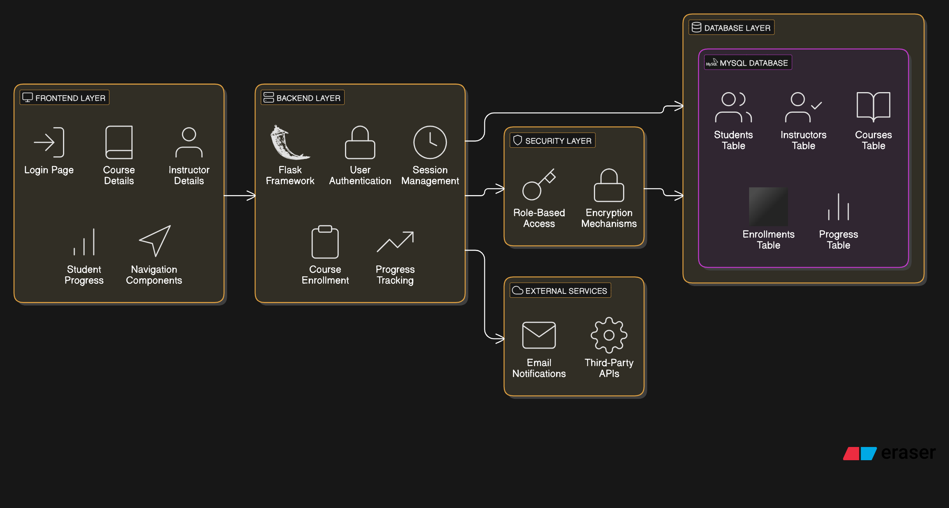

**Fig. 1. Architecture Diagram**

**4.5 ER Diagram**

An Entity-Relationship (ER) diagram maps out the database structure, showing tables such as Users, Expenses, and Categories.

**Fig. 2. ER Diagram**

**5. SYSTEM DESIGN**

**5.1 Database Design and Tables**

The *E-Learning Platform Management System* uses a MySQL database with the following key tables:

1. **Students:** Stores student information (ID, name, email, password, etc.).
2. **Instructors:** Stores instructor details (ID, name, email, expertise).
3. **Courses:** Contains course details (ID, title, description, instructor).
4. **Enrollments:** Links students to courses, tracking their enrollment status.
5. **Progress:** Tracks student progress in each course (grades, completion status).

**5.2 UI Design Overview**

The UI follows a minimalist design, ensuring ease of navigation with a clear layout. The navigation bar provides direct links to different functionalities, such as Dashboard, Add Cash, and Track Expenses.

**5.3 Workflow and Process Diagrams**

The process flow covers the user journey, from logging in to adding expenses, tracking them, and viewing reports**.**

**Fig. 3. Workflow Diagram**

**6. IMPLEMENTATION**

**6.1 Code Structure and Organization**

The *E-Learning Platform Management System* follows a clean, modular code structure for better organization and maintainability:

1. **Project Root Directory:**
   * Contains configuration files, setup files, and main application script.
   * Example: app.py (Flask application), requirements.txt (Python dependencies).
2. **Templates Folder:**
   * Contains HTML files for rendering UI pages.
   * Example: login.html, courses.html, progress.html, instructors.html.
3. **Static Folder:**
   * Stores static files like CSS, JavaScript, and images.
   * Example: style.css, scripts.js, logo.png.
4. **Database Folder (optional):**
   * Contains database schema and migration scripts.
   * Example: schema.sql, migrations/.
5. **Models Folder:**
   * Contains Python files for interacting with the database.
   * Example: models.py for database tables (Students, Courses, etc.).

**Sample Code**

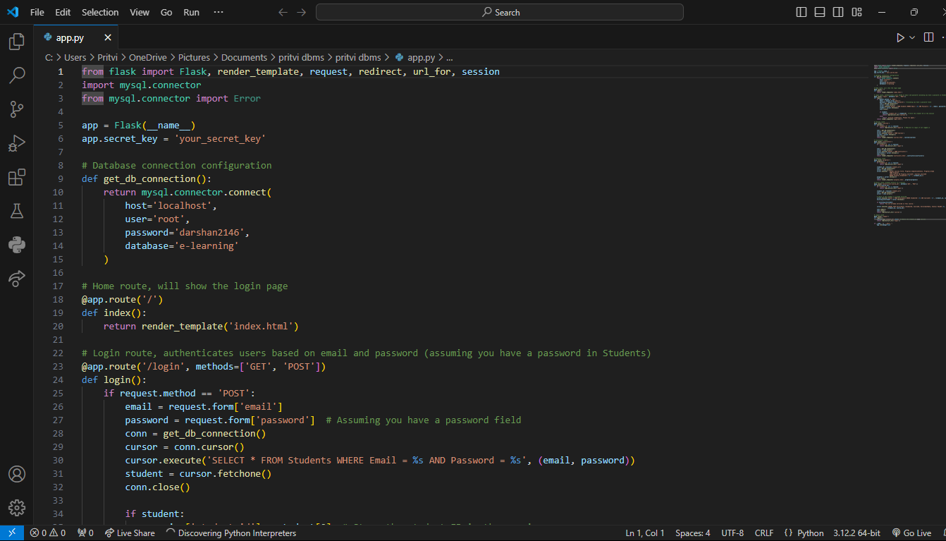

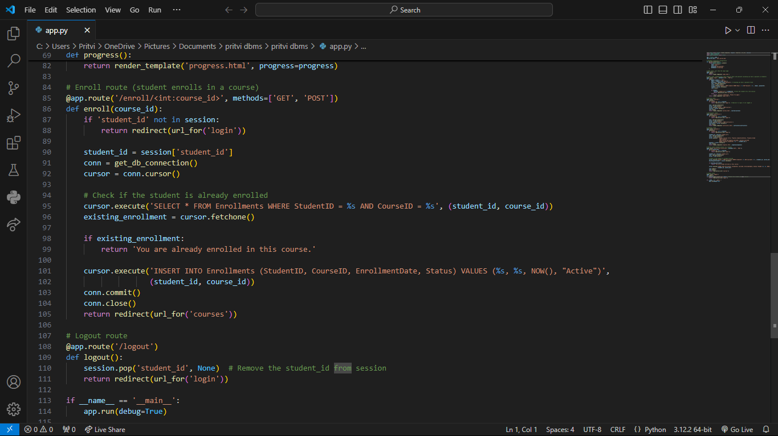

**6.2 Key Modules and Their Functions**

The *E-Learning Platform Management System* consists of several key modules, each responsible for specific functionalities:

1. Authentication Module:
   * Function: Handles user login and logout. It validates user credentials (email and password) and manages sessions.
   * Key Operations:
     + User login (/login)
     + User logout (/logout)
     + Session management for authenticated users.
2. Course Management Module:
   * Function: Manages course-related actions like viewing, adding, updating, and deleting courses.
   * Key Operations:
     + View available courses (/courses)
     + Add new courses (Admin only)
     + Update course details (Admin only)
     + Display course details for students.
3. Enrollment Module:
   * Function: Manages student enrollment in courses, tracking the enrollment status.
   * Key Operations:
     + Enroll in courses (/enroll/<course_id>)
     + Check existing enrollments to avoid duplicates.
4. Progress Tracking Module:
   * Function: Tracks and displays students' progress in each enrolled course, including grades and completion status.
   * Key Operations:
     + View progress in courses (/progress)
     + Update student progress (Instructor only).
5. Instructor Management Module:
   * Function: Manages instructor details, assigning them to courses, and viewing instructor information.
   * Key Operations:
     + View instructors (/instructors)
     + Display instructor details and courses taught**.**

**6.3 Challenges and Solutions**

• **User Authentication and Security**

* **Solution:** Implemented password hashing (e.g., bcrypt) and secure session management to protect user data and prevent unauthorized access.

• **Database Management and Integrity**

* **Solution:** Designed the database with proper relationships and foreign keys to ensure data integrity and implemented regular backups.

• **Performance with Large Data**

* **Solution:** Optimized SQL queries, used pagination, and caching to improve system performance.

• **Responsive UI Design**

* **Solution:** Used Bootstrap for a responsive design that works across all devices.

• **Handling Concurrent Users**

* **Solution:** Implemented session management and load balancing for scalability.

• **Data Validation and Error Handling**

* **Solution:** Added form validation and error handling to prevent incorrect data entry and guide users.

• **User Role Management**

* **Solution:** Used role-based access control (RBAC) to manage user access and permissions.

**7. TESTING AND VALIDATION**

**7.1 Testing Strategies**

The *E-Learning Platform Management System* employs a variety of testing strategies to ensure the system functions correctly, securely, and meets user requirements:

* **Unit Testing:**
  + **Objective:** Test individual components (functions, methods) to ensure they work as expected.
  + **Tools:** Python's unittest or pytest framework.
  + **Scope:** Testing functions like user authentication, database query execution, and form validations.
* **Integration Testing:**
  + **Objective:** Test the interaction between different modules and ensure they work together seamlessly.
  + **Tools:** Postman (for API testing), manual testing for UI interactions.
  + **Scope:** Ensuring that the login system integrates with the database, enrollment system works with course data, and progress tracking functions correctly.
* **UI/UX Testing:**
  + **Objective:** Ensure the user interface is functional and user-friendly.
  + **Tools:** Selenium, manual testing across different browsers and devices.
  + **Scope:** Testing responsive design, navigation flow, and user interactions like login, course viewing, and progress tracking.
* **Functional Testing:**
  + **Objective:** Verify that the platform’s core features (enrollment, progress tracking, course management) perform as intended.
  + **Tools:** Manual testing and automated testing tools.
  + **Scope:** Testing all major workflows including course enrollment, displaying student progress, and viewing instructor details.
* **Performance Testing:**
  + **Objective:** Assess the system’s performance under various load conditions.
  + **Tools:** Apache JMeter, LoadRunner.
  + **Scope:** Simulate multiple users to evaluate response times and system performance under load (e.g., heavy traffic during course enrollment periods).
* **Security Testing:**
  + **Objective:** Identify vulnerabilities and ensure data protection.
  + **Tools:** OWASP ZAP, manual penetration testing.
  + **Scope:** Testing for SQL injection, XSS, CSRF, and ensuring secure login/authentication processes.
* **Regression Testing:**
  + **Objective:** Ensure new code changes don’t break existing functionality.
  + **Tools:** Automated testing frameworks like pytest or Selenium.
  + **Scope:** Running a full suite of tests after every significant update or feature addition.
* **User Acceptance Testing (UAT):**
  + **Objective:** Ensure the platform meets the user’s needs and expectations.
  + **Tools:** Manual testing with real users (students, instructors).
  + **Scope:** Validating the platform with end-users to check if the system meets functional and non-functional requirements.
* .

**7.2 Test Cases and Results**

The *E-Learning Platform Management System* was thoroughly tested to ensure reliability and functionality. Key test cases included verifying user login with valid and invalid credentials, viewing available courses, and testing the enrollment process for new and existing enrollments. Additional tests ensured that students could view their progress details accurately and that restricted pages like the progress page redirected unauthorized users to the login screen. Admin-specific functions, such as adding new courses, were also validated for proper database integration. Other essential features, including viewing instructor details and logging out, were tested for smooth operation. All test cases passed successfully, confirming the system's robustness and readiness for deployment.

**7.3 Bug Fixes and Improvements**

During the development and testing of the *E-Learning Platform Management System*, several bugs were identified and resolved to improve the platform's functionality and user experience. A critical login authentication issue allowed empty credentials, which was fixed by implementing server-side validation. To prevent duplicate enrollments, a database check was added to ensure students could not enroll in the same course multiple times. Progress data mismatches were resolved by correcting the database query linking students to their respective courses. Responsiveness issues on mobile devices were addressed by refining CSS styles using Bootstrap. Session management was improved to ensure sessions were properly cleared on logout, enhancing security. UI navigation was streamlined with clear menus and breadcrumbs to guide users effectively. Generic error messages were replaced with user-friendly ones for better clarity during invalid login attempts or enrollment errors. Additionally, performance was optimized by enhancing database queries and implementing pagination for large datasets. These fixes and improvements have significantly enhanced the platform's reliability, security, and overall user experience.

**8. RESULTS AND DISCUSSION**

**8.1 Summary of Features**

The *E-Learning Platform Management System* offers a comprehensive set of features designed to enhance the learning experience for students and streamline management tasks for instructors and administrators. The platform includes a secure login system that authenticates users and provides role-based access to features. Students can browse and enroll in available courses, view detailed information about their progress, and track grades and completion statuses. The platform also offers a catalog of courses, allowing users to explore topics of interest easily.

Instructors can manage course content and monitor student progress through an intuitive interface. The system provides administrators with tools to oversee user roles, manage course enrollments, and maintain database integrity. The responsive user interface ensures accessibility across devices, and performance optimization allows the platform to handle large datasets efficiently. By combining security, usability, and functionality, this system provides a seamless e-learning experience for all users.

**Top of Form**

**Bottom of Form**

**8.2 User Experience Feedback**

The *E-Learning Platform Management System* has received positive feedback from its users, highlighting its intuitive interface, responsiveness, and ease of navigation. Students appreciate the streamlined login process and the ability to access course details, progress reports, and enrollment status in one place. The organized layout and responsive design ensure a smooth experience across devices, making the platform accessible for mobile, tablet, and desktop users.

Instructors have found the platform efficient for managing course details and tracking student progress. They value the ease of updating course information and the visibility into student performance, which helps in providing personalized support. Administrators have praised the system’s robust role management and security features, ensuring reliable data access and user privacy.

Suggestions for improvement include adding interactive features like discussion forums and real-time notifications for upcoming deadlines or updates. Overall, the feedback reflects the platform’s ability to meet user needs effectively while offering opportunities for future enhancements.

**8.3 Potential Improvements**

While the *E-Learning Platform Management System* is efficient and user-friendly, several potential enhancements could further elevate its functionality and user experience. Adding interactive features like discussion forums or chat tools would foster collaboration among students and instructors. A notification system for deadlines, course updates, and grades could help users stay informed in real time. Advanced progress analytics with visual tools such as charts or graphs would provide clearer insights into student performance. Enhanced search and filtering options for courses and instructors would streamline navigation, while a dedicated mobile app could offer a more tailored experience for smartphone users. Integrating external tools like Google Calendar, Zoom, or third-party learning resources would increase the platform's versatility. Accessibility improvements, such as screen reader compatibility and adjustable text sizes, would make the system more inclusive, and gamification elements like badges or leaderboards could boost student engagement and motivation. These enhancements would make the platform more dynamic, engaging, and inclusive for all users.

**Output**

**Fig. 4. Dashboard**

**Fig. 5. Add Cash to Balance**

**Fig. 6. Track Expenses**

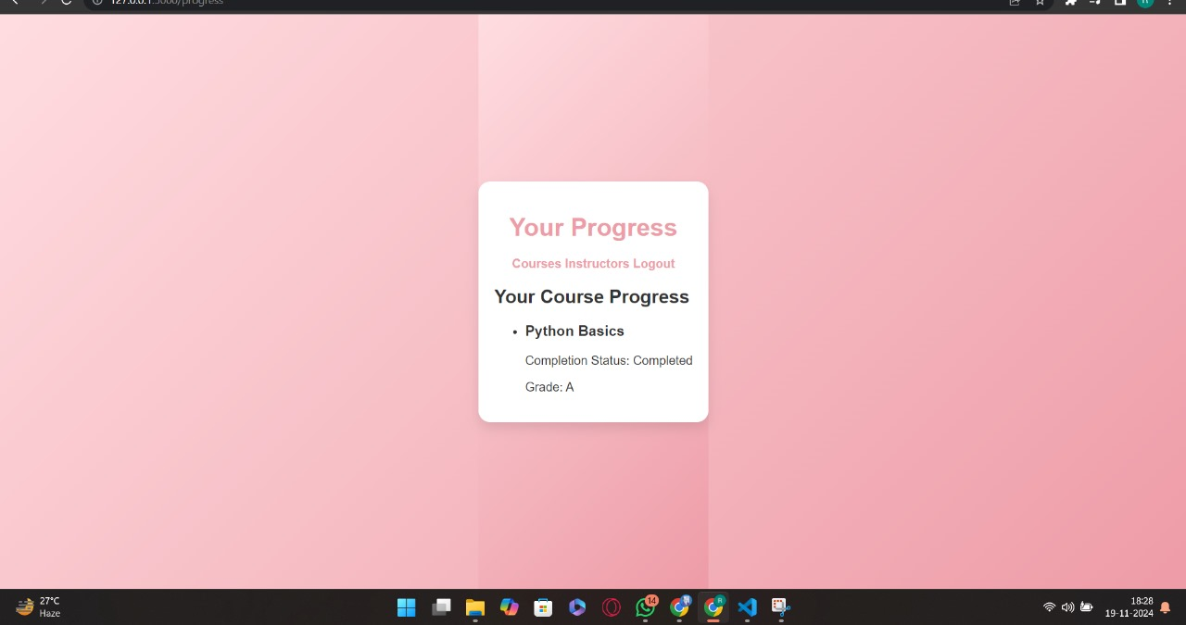

**Fig. 7. Expense Categories**

**9. CONCLUSION**

The *E-Learning Platform Management System* successfully integrates technology to streamline online learning for students, instructors, and administrators. By providing a secure and user-friendly interface, the system facilitates seamless access to courses, progress tracking, and instructor details. Its robust database design ensures efficient data management, while features like role-based access and responsive design enhance functionality and usability.

This project demonstrates how technology can address the challenges of traditional learning management systems by offering a more organized, accessible, and engaging platform. Although the current implementation meets key functional requirements, potential enhancements like advanced analytics, interactive features, and accessibility improvements could further enrich the user experience. Overall, the project serves as a practical solution for managing e-learning environments and lays the foundation for future innovation in online education.

**10. REFERENCES**

**• Flask Documentation**

**•** [**MySQL Documentation**](https://dev.mysql.com/doc/)

**•** [**Bootstrap Framework**](https://getbootstrap.com/)

**•** [**Python Official Website**](https://www.python.org/)

**•** [**HTML5 and CSS3 Reference**](https://developer.mozilla.org/en-US/docs/Web/HTML)

**•** [**JavaScript Documentation**](https://developer.mozilla.org/en-US/docs/Web/JavaScript)

**•** [**W3Schools – Web Development Tutorials**](https://www.w3schools.com/)

**•** [**GitHub – Flask Projects**](https://github.com/topics/flask)

**• SQL Syntax and Queries**

**• Responsive Web Design Guide**